Chapter 6

Questions and Problems and Answers

- Explain why option traders often use spreads instead of simple long or short options and combined positions of options and stock.
Simple long or short positions expose the trader to considerable risk. This is especially true for short positions. By taking an opposite position in another option, i.e. , executing a spread, the trader is able to keep the risk to a more manageable level. Combined positions of options and stocks do the same thing, the options serves as a hedge for the stock or the stock serves as a hedge for the option. However, a position in both options and stock is harder to execute since the options and stocks trade in different markets. This results in time delays in getting the trades executed. On the other hand, a spread can be executed much faster, with both transactions done almost simultaneously in the same market.
- Suppose an option trader has a call bull spread. The stock price has risen substantially, and the trader is considering closing the position early. What factors should the trader consider with regard to closing the transaction before the options expire?
Since the stock price is closer to the higher exercise price than to the lower exercise price, the short call at the higher exercise price has the greater time value. Therefore, holding the position longer could result in a greater time value decay on the short call than on the long call. This will occur only, however, if the stock price does not move down. The cross-over point indicated in figure 6.2 in the chapter is a critical stock price below which a shorter holding period is preferred. If it appears as if the stock price will fall below the cross-over stock price, the position should be closed as soon as possible, but only if the stock price is not expected to turn back around before the option expires.
- Suppose you are following the stock of a firm that has been experiencing severe problems. Failure is imminent unless the firm is granted government guaranteed loans. If the firm fails, its stock will, of course, fall substantially. If the loans are granted, it is expected that the stock will rise substantially. Identify two strategies that would be appropriate for this situation. Justify your answers.
Both a straddle and a time spread can be used in this situation. A straddle consisting of the purchase of a put and a call with identical exercise prices and expirations would profit if the stock price move substantially in either direction. A time spread consisting of the sale of a longer-term option and the purchase of a shorter-term option would also profit if the stock price move significantly in either direction. This is because a large stock price move will allow repurchase of the longer term options when it has little time value remaining. Note that this example is the opposite of the one discussed in the text. Also, a butterfuly spread that is short the high and low exercise prices and long two of the middle exercise price could be used in this situation, but it would have limited gains if the stock price moved substantially.
- Explain why in some situations a put bear spread could offer an advantage over a similar call bear spread.
A put bear spread could offer two advantages over a call bear spread. First, it is possible that the puts could be mispriced while the calls are correctly priced. Second, a call bear spread runs the risk of early exercise. The short call can be in-the-money without the long call also being in-the-money. For the put bear spread, however, the short put will not be in-the-money unless the long put is also. Then if the short put is exercised, the long put can be exercised for a net gain of – (E₁ – S_{t} ) + (E₂ – S_{t} ) = E₂ - E₁ which is the maximum value that could be expected by holding the position to expiration.
- Derive the profit equations for a put bull spread. Determine the maximum and minimum profits and the breakeven stock price at expiration.
Buy one put with exercise price E₁ and sell one put with exercise price E₂.
The profit equation is
Π = Max (0, E₁ – S_{T} ) - P₁ - Max(0, E₂ – S_{T} ) + P₂
If S_{T} < E₁ < E₂
Π = E₁ – S_{T} - P₁ - E₂ + S_{T} + P₂
= E₁ – E₂ - (P₁ - P₂)
Recall form chapter 3 that the difference between the exercise prices is less than the difference between premiums. Since E₁ < E₂ and P₁ < P₂, the above profit is negative.

If E₁ < S_{T} < E₂
Π = - P₁ - E₂ + S_{T} + P₂

This figure increases dollar for dollar with S_{T} . The breakeven is found by setting the profit to zero,
- P₁ - E₂ + S_{T} * + P₂ = 0
And solving for S_{T} *
S_{T} * = E₂ +(P₁ - P₂ )

If E₁ < E₂ < = S_{T}
Π = - P₁ + P₂

Since P₂ > P_{1,} this figure is positive.

The minimum profit occurs in the first profit range, S_{T} < E₁ < E₂ and equals E₁ – E₂ - (P₁ - P₂). The maximum profit occurs in the third profit range, E₁ < E₂ < = S_{T} and equals - P₁ + P₂

- Explain the process by which the profit of a short straddle closed out prior to expiration is influenced by the time values of the put and call.
First note that the graph for a short straddle held to expiration is an inverted V. If closed out prior to expiration, a short straddle ( which involves the sale of both a put and a call) will require the repurchase of both options. This means that prior to expiration, there will be time values on both the put and the call that will have to be repurchased. These time values are highest if the stock price is close to the exercise price. So the profit if the stock price is near the exercise price is lower the shorter the holding period. The longer the investor can hold the position, the less time value that remains on the options. However, this also gives the stock more time to move substantially and potentially generate a large loss.
- Explain why selecting a strap over a straddle implies a slightly more bullish outlook.
If the investor feels that the market is as likely to go down as up, a straddle would be an appropriate strategy because the profit graph is symmetric. If the investor feels slightly more bullish than bearish, then the addition of a second call enables the investor to capitalize if the market goes up. However, the cost of the second call must be recovered, and in a strong bear market or one in which the stock price does not move much in either direction, the cost of the second call cuts significantly into the profit. A strap is like placing more money on the line that the market will go up. Unless you are right and the market goes up enough to enable you to exercise or sell the calls and recover the premiums paid, then your profit will be lower.
- The chapter showed how analyzing a box spread is like a capital budgeting problem using the net present value approach. Consider the internal rate of return method of examining capital budgeting problems and analyze the box spread in that context.
In internal rate of return (Capital IRR) problems, the return from the investment is compared to the opportunity cost of capital. The investment is acceptable if the IRR exceeds the opportunity cost. In the box spread problem, the investment pays E₂ - E₁ . The initial outlay is C₁ - C₂ – P₁+ P₂ . The IRR is the value of i that solves
(E₂ - E₁ ) (1 + i )^{-T} = C₁ - C₂ – P₁+ P₂
The opportunity cost is the risk-free rate, r . If i is greater than r, then the box spread is acceptable. If i is less than r, then the box spread is overpriced and should be reversed.
The following option prices were observed for calls and puts on a stock on July 6 of a particular year. Use this information for problems 9 through 21. The stock was priced at 165 1/8. The expirations are July 17, August 21, October 16. The continuously compounded risk-free rates associated with the three expirations are 0.0503, 0.0535, 0.0571, respectively. The standard deviation is 0.21.

Strike | Calls |  |  | Puts
Strike | July | Aug | Oct | Jul | Aug | Oct
160 | 6 | 8 1/8 | 11 1/8 | ¾ | 2 ¾ | 4 ½
165 | 2 11/16 | 5 ¼ | 8 1/8 | 2 3/8 | 4 ¾ | 6 ¾
170 | 13/16 | 3 ¼ | 6 | 5 ¾ | 7 ½ | 9

For problems 9 through 12 and 15 through 18, determine the profits for the holding period indicated for possible stock prices of 150, 155, 160, 165, 170, 175 and 180 at the end of the holding period. Answer any other questions as indicated. Note: Your Excel spreadsheet stratlyz1.xls will be useful here for obtaining graphs as requested but it does not allow you to calculate the profits for several user-specified asset prices. It permits you to specify on asset price and a maximum and minimum. Use stratlyz1.xls to produce the graph for the range of prices and 150 to 180 but determine the profits for the prices of 150, 155,….,180 by hand for positions held to expiration. For positions closed prior to expiration, use the spreadsheet bsbin1.xls or the Windows program bsbwin2.exe to determine the option price when the position is closed; then calculate the profit by hand.

- Construct a bear money spread using the October 165 and 170 calls. Hold until the options expire. Determine the profits and graph the results. Identify the breakeven stock price at expiration and the maximum and minimum profits.

Buy the October 170 at 6
Sell the October 165 at 8.125

S_{T} | Call Price at End of Holding Period |  | Profit
 | October 170 | October 165
150 | 0 | 0 | 212.5
155 | 0 | 0 | 212.5
160 | 0 | 0 | 212.5
165 | 0 | 0 | 212.5
170 | 0 | 5 | -287.5
175 | 5 | 10 | -287.5
180 | 10 | 15 | -287.5

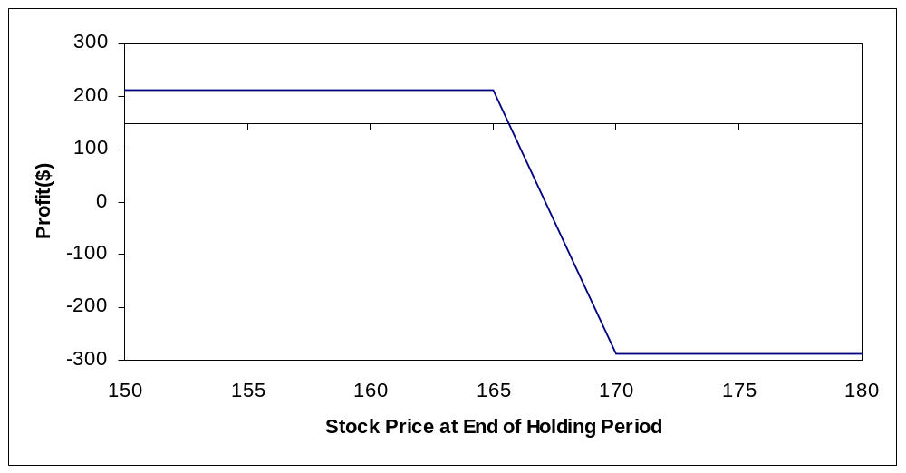

Breakeven stock price:

Maximum Profit : 212.50
Minimum Profit: -287.50
- Repeat problem 9, but close the position on September 20. Calculate the profit by hand when the stock price on September 20 is 155. Then use the spreadsheet or calculate by hand to find the profits for the possible stock prices on September 20. Generate a graph and use it to identify the approximate breakeven stock price
Time to expiration: 26/365 = 0.0712
(26 days between September 20 and October 16)
r_{c} = 0.0571

By hand with S_{T} = 155
165 Call

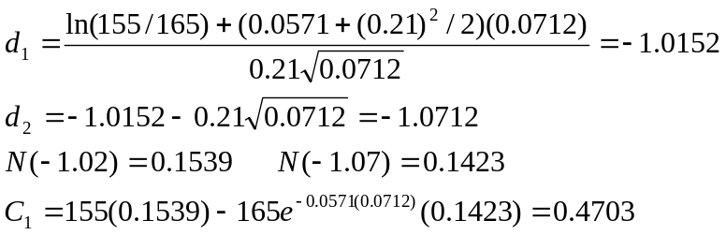 .
170 Call

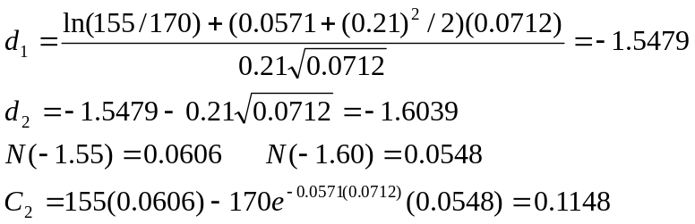 .

Spread Value = 0.1148 – 0.4703 =- 0.3555
Π = 100(-0.3555-6+8.125) = 176.95

The results are noticeably different from the values computed using a spreadsheet (see below), but the difference is due to the Black-Scholes model’s sensitivity to round-off errors.

S_{T} | Call Price at End of Holding Period |  | Profit
 | October 165 | October 170
150 | 0.1911 | 0.0487 | 198.26
155 | 0.6856 | 0.2232 | 166.26
160 | 1.8633 | 0.7546 | 101.63
165 | 4.0250 | 1.9698 | 6.98
170 | 7.2353 | 4.1469 | -96.34
175 | 11.2927 | 7.3433 | -182.44
180 | 15.8803 | 11.3707 | -238.46

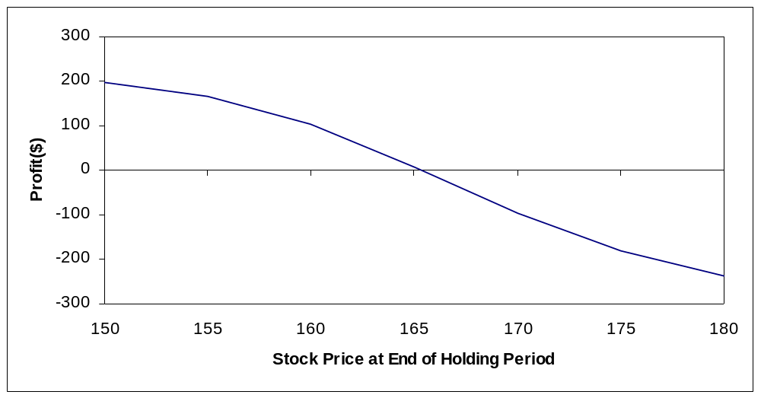

Approximate breakeven : 166

- Suppose you are expecting the stock price to move substantially over the next three months. You are considering a butterfuly spread. Construct an appropriate butterfuly spread using the October 160, 165, and 170 calls. Hold the position until expiration. Determine the profits and graph the results. Identify the two breakeven stock prices and the maximum and minimum profits.

Sell October 160 at 11.125
Buy two October 165’s at 8.125 each
Sell October 170 at 6

S_{T} | Call Price at End of Holding Period |  |  | Profit
 | October 160 | October 165 | October 170
150 | 0 | 0 | 0 | 87.50
155 | 0 | 0 | 0 | 87.50
160 | 0 | 0 | 0 | 87.50
165 | 5 | 0 | 0 | -412.50
170 | 10 | 5 | 0 | 87.50
175 | 15 | 10 | 5 | 87.50
180 | 20 | 15 | 10 | 87.50

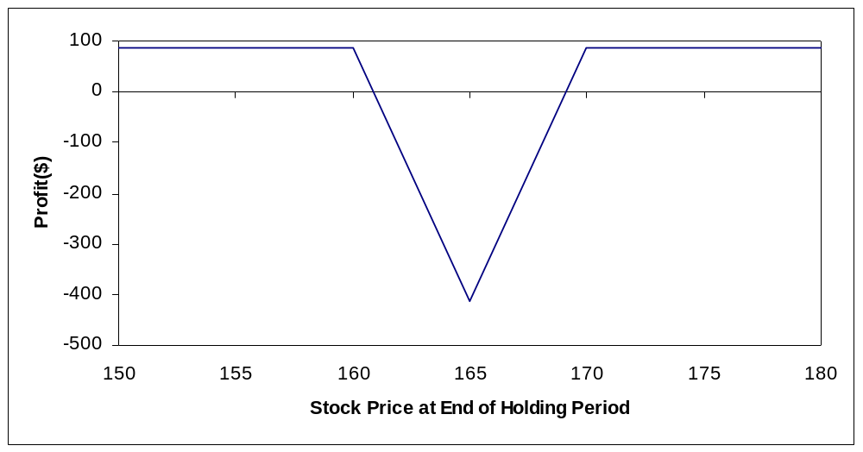

Breakevens:

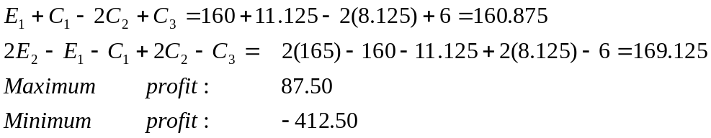
- Construct a calendar spread using the August and October 170 calls that will profit from high volatility. Close the position on August 1. Calculate the profit by hand when the stock price on August 1 is 155. Then use the spreadsheet or calculate by hand to find the profits for the possible stock prices on August 1. Generate a graph and use it to estimate the maximum and minimum profits and breakeven stock prices.

Buy August 170 at 3.25
Sell October 170 at 6

August 170: T=20/365=0.0548 r_{c} = 0.0535
October 170: T=76/365=0.2082 r_{c} = 0.0571

(Based on 20 days between August 1 and August 21, and 76 days between August 1 and October 16)

By hand with S_{T} = 155

August 170

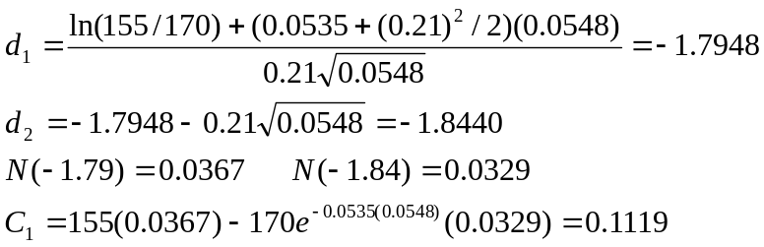 .
October 170

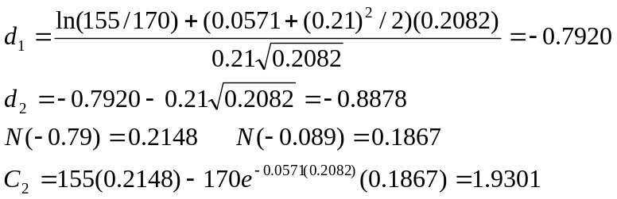 .

Spread Value = 0.1119-1.9301 = -1.8182
Π= 100(-1.8182-3.25+6)=93.18

These results are noticeably different from the values computed using a spread sheet (see below), but the difference is due to the Black-Scholes model’s sensitivity to the round-off errors.

S_{T} | Call Price at End of Holding Period |  | Profit
 | August 170 | October 170
150 | 0.0164 | 0.8844 | 188.2
155 | 0.1083 | 1.7301 | 112.82
160 | 0.4793 | 3.0639 | 16.53
165 | 1.5084 | 4.9781 | -71.97
170 | 3.5836 | 7.5118 | -117.83
175 | 6.8145 | 10.6446 | -108.01
180 | 10.9577 | 14.3064 | -59.87

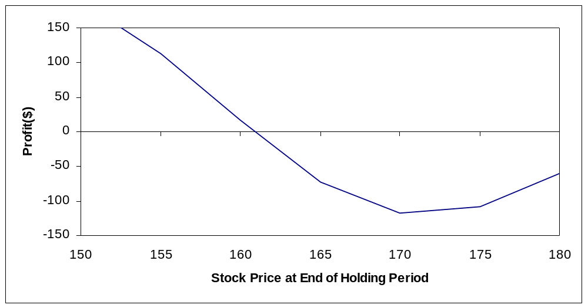
Maximum profit: 275 [if S_{T} = 0, profit = -100(3.25-6)=275]
Minimum profit: -117.53
Approximate breakevens : 161 and 181

- Using the Black-Scholes model, compute and graph the time value decay of the October 165 call on the following dates: July 15, July 31, August 15, August 31, September 15, September 30, and October 16. Assume the stock price remains constant. Calculate the time value on July 15 by hand and then use the spreadsheet or calculate by hand to find the time value in all of the cases.

Using the Black-Scholes models with r_{c} = 0.0571
On July 15, T=(16+31+30+16)/365 = 0.2548
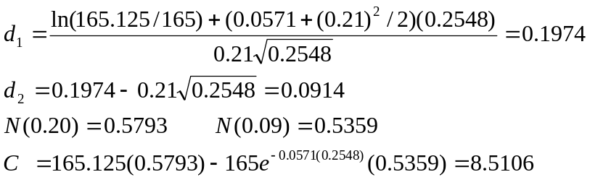

Intrinsic value = Max(0, 165.125-165)=0.125
Time Value = 8.5106-0.125 = 8.3856
This differs substantially from the value computed using a spreadsheet (see below) but the difference is due to the Black-Scholes model’s sensitivity to round-off errors.

Date | Time to Expiration | Time Value
7/15 | 0.25480 | 8.1278
7/31 | 0.21100 | 7.2918
8/15 | 0.16990 | 6.4452
8/31 | 0.12600 | 5.4473
9/15 | 0.08490 | 4.3732
9/30 | 0.04380 | 3.0431
10/16 | 0.00000 | 0.0000
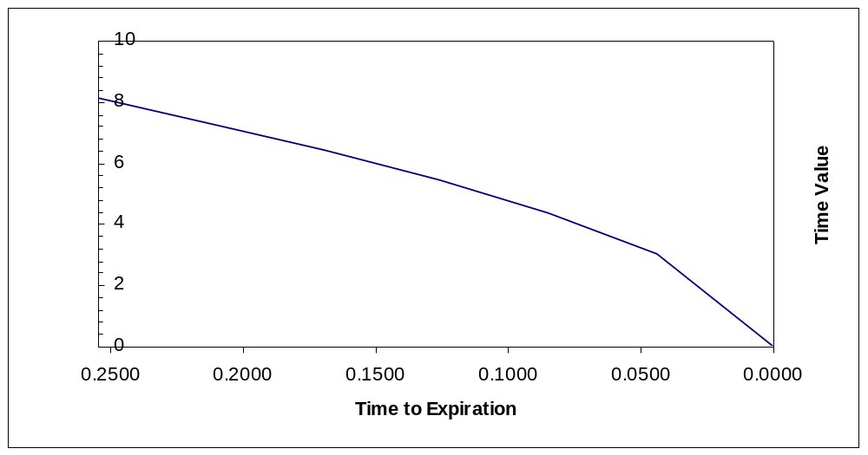

- Consider a riskless spread with a long position in the August 160 call and a short position in the October 160 call. Determine the appropriate hedge ratio. Then show how a $1 stock price increase would have a neutral effect on the spread value. Discuss any limitations of this procedure.

Using a spreadsheet for the Black-Scholes Model
August 160

The delta (N(d₁)) is found to be 0.7091
October 160
The delta (N(d₁)) is found to be 0.6855
If we buy the August 160 and write the October 160, the hedge ratio is the delta of the August call divided by the delta of the October call
0.7091/0.6855 = 1.0344
So sell 1.0344 October calls for each August call.
Suppose we buy 1000 August calls and sell 1034 October call. If the stock price increases by $1, the August calls increase by 0.7091 each for a total gain of $709. The October calls increase by 0.6855 each for a total loss (since we are short) of 1034 (0.6855) = $709
The procedure is valid only for very small changes in the stock price. Otherwise the hedge could have significant gamma risk.

- Construct a long straddle using the October 165 options. Hold until the options expire. Determine the profits and graph the results. Identify the breakeven stock prices at expiration and the minimum profit.

Buy the October 165 call at 8.125
Buy the October 165 put at 6.75

S_{T} | Option Price at End of Holding Period |  | Profit
 | October 165 Call | October 165 Put
150 | 0 | 15 | 12.50
155 | 0 | 10 | -487.50
160 | 0 | 5 | -987.50
165 | 0 | 0 | -1487.50
170 | 5 | 0 | -987.50
175 | 10 | 0 | -487.50
180 | 15 | 0 | 12.50

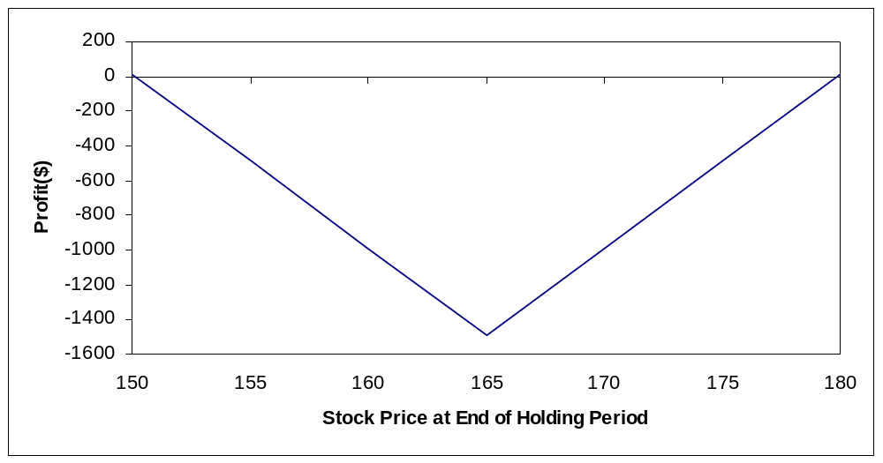

Breakevens:
E + C + P = 165 + 8.125 + 6.75 = 179.875
E – C – P = 165 – 8.125 – 6.75 = 150.125
Minimum profit: -1,487.50

- Repeat problem 15, but close the positions on September 20. Calculate the profit by hand when the stock price on September 20 is 155. Then use the spreadsheet or calculate by hand to find the profits for the possible stock prices on September 20. Generate a graph and use it to identify the approximate breakeven stock prices.

r_{c} = 0.0571 T = 26/365 = 0.0712
By hand with S_{T} = 155:

This value is calculated by hand in problem 6-10. C = 0.4703. with N(d₁) = 0.1539 and N(d₂) = 0.1423, the value of the put is

P =
Straddle Value = 0.4703 + 9.8008 = 10.2711
Π = 100(10.2711-8.125-6.75)= -460.39

These results are noticeably different from the values computed using a spreadsheet (see below), but the difference is due to the Black-Scholes model’s sensitivity to round-off errors.

S_{T} | Option Price at End of Holding Period |  | Profit
 | October 165 Call | October 165 Put
150 | 0.1911 | 14.5217 | -16.22
155 | 0.6856 | 10.0162 | -417.32
160 | 1.8633 | 6.1939 | -681.78
165 | 4.0250 | 3.3555 | -749.45
170 | 7.2353 | 1.5658 | -607.39
175 | 11.2927 | 0.6233 | -295.90
180 | 15.8803 | 0.2109 | 121.62

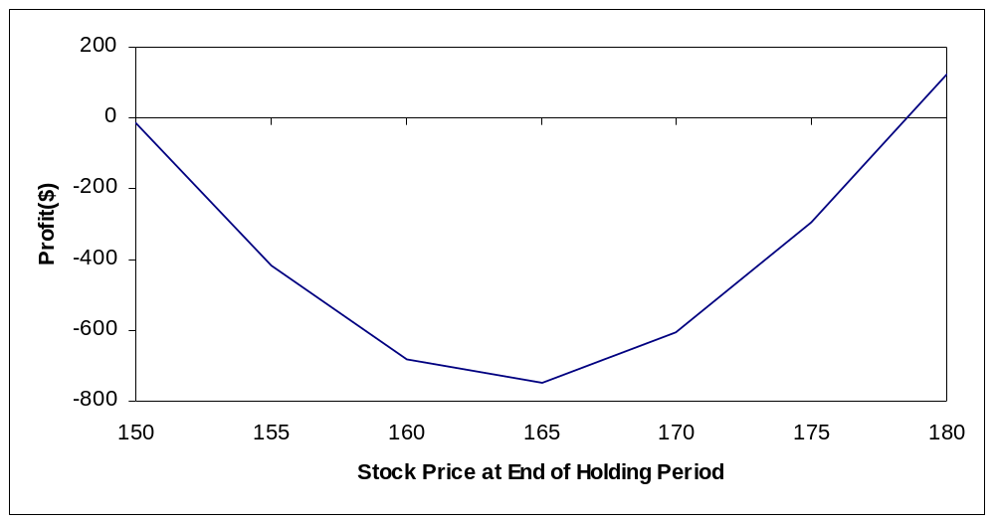
Approximate breakevens : 178 and 150

- Construct a long strap using the October 165 options. Hold the position until expiration. Determine the profits and graph the results. Identify the breakeven stock prices at expiration and the minimum profit. Compare the results with the October 165 straddle.

Buy two October 165 calls at 8.125 each
Buy one October 165 put at 6.75

S_{T} | Option Price at End of Holding Period |  | Profit
 | October 165 Call | October 165 Put
150 | 0 | 15 | -800.00
155 | 0 | 10 | -1,300.00
160 | 0 | 5 | -1,800.00
165 | 0 | 0 | -2,300.00
170 | 5 | 0 | -1,300.00
175 | 10 | 0 | -300.00
180 | 15 | 0 | 700.00

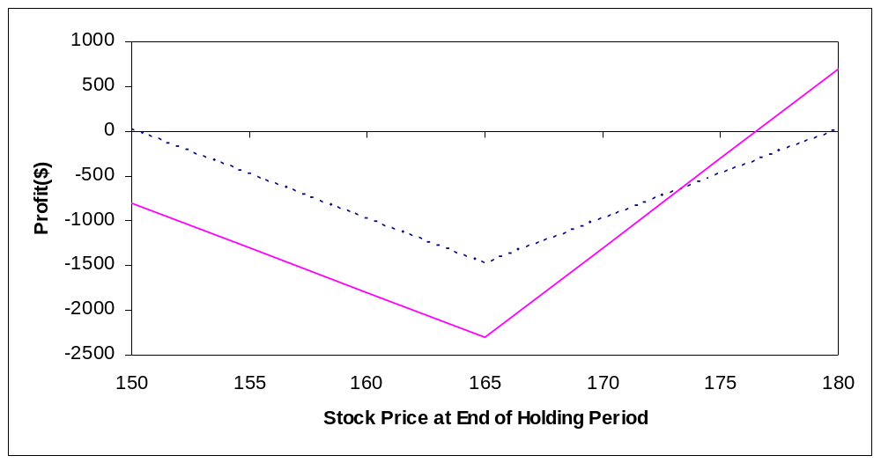

The graph shows the straddle (the dashed line) overlayed with the strap. The strap provides a higher profit on the upside and a larger loss on the downside.

Breakevens:

E+C+P/2 = 165+8.125+6.75/2 = 176.50
E-P-2C= 165-6.75-2(8.125) = 142
Minimum profit: -100(2(8.125)+6.75) = -2,300

- Construct a short strip using the August 170 options. Hold the position until the options expire. Determine the profits and graph the results. Identify the breakeven stock prices at expiration and the minimum profit.

Sell two August 170 puts at 7.5
Sell one August 170 call at 3.25

S_{T} | Option Price at End of Holding Period |  | Profit
 | August 170 Call | August 170 Put
150 | 0 | 20 | -2,175.00
155 | 0 | 15 | -1,175.00
160 | 0 | 10 | -175.00
165 | 0 | 5 | 825.00
170 | 0 | 0 | 1,825.00
175 | 5 | 0 | 1,325.00
180 | 10 | 0 | 825.00

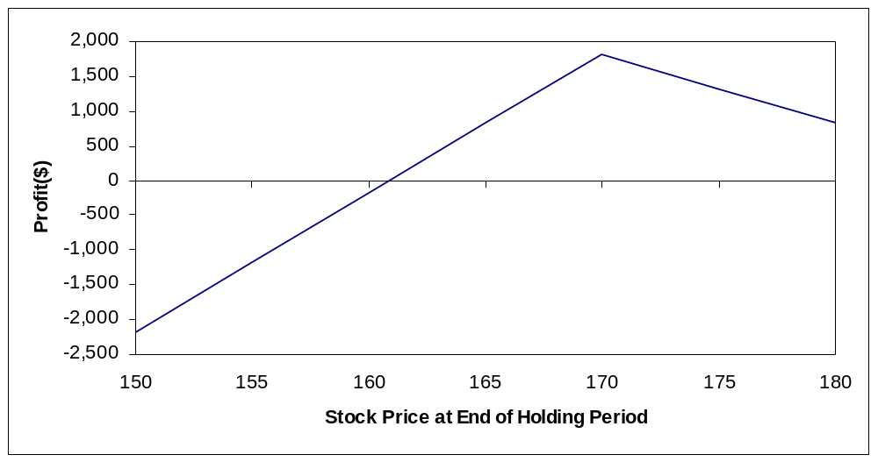
Note that only one breakeven point appears in the graph because of the range of the stock prices chosen.
Breakevens:

E+C+2P = 170+3.25+2(7.5) = 188.25
E-P-C/2 = 170-7.5-3.25/2 = 160.875

Minimum profit:
When S_{T} = 0, π= C+2P-2E = 100[3.25+2(7.5)-2(170)] = -32,175

- Analyze the August 160/170 box spread. Determine whether a profit opportunity exists and, if so, how one should exploit it.

Note : If the continuously compounded rate is 0.0535 then the discrete rate is
^{e0.0535} -1 = 0.055
buy August 160 call at 8.125.
Sell August 170 call at 3.25.
Buy August 170 put at 7.5.
Sell August 160 put at 2.75
The net premium is
8.125-3.25+7.5-2.75 = 9.625
The present value of the future payoff is
(170-160)(1.055)^{-0.1260} = 9.933
Where 0.1260 is the time to expiration from July 6 to Aug 21. Thus the net present value is
9.933 – 9.625 = 0.308
This spread is under priced so buy it. That is, buy the August 160 call and 170 put and sell the August 170 call and 160 put. This will generate a negative cashflow upfront of 9.625. At expiration you will receive 10, but the present value of 10 is more than the initial cashflow.
- (Concept Problem) The chapter presented two variations of the straddle: straps and strips. Another variation of the straddle is called a strangle. A strangle is the purchase of a call with a higher exercise and a put with a lower exercise price. Evaluate the strangle strategy by examining the purchase of the August 165 put and 170 call. As in the problems above, determine the profits for stock prices of 150, 155, 160, 165, 170, 175, and 180. Hold the position until expiration and graph the results. Find the breakeven stock prices at expiration. Explain why one would want to use a strangle.

Buy August 165 put at 4.75.
Buy August 170 call at 3.25.

S_{T} | Option Price at End of Holding Period |  | Profit
 | August 165 Put | August 170 Call
150 | 15 | 0 | 700.00
155 | 10 | 0 | 200.00
160 | 5 | 0 | -300.00
165 | 0 | 0 | -800.00
170 | 0 | 0 | -800.00
175 | 0 | 5 | -300.00
180 | 0 | 10 | 200.00

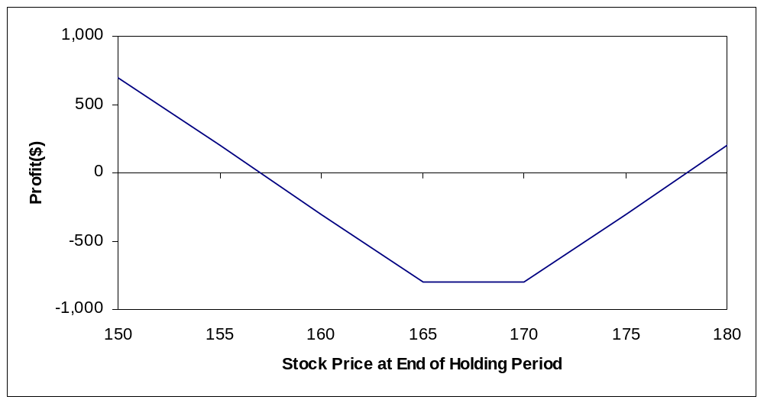

Breakevens:

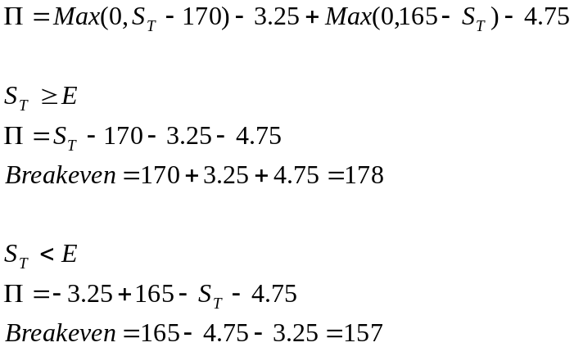

The strangle is similar to a straddle. However, by using a lower exercise price put or higher exercise price call the cost is lower, though the profit is also lower.

- (Concept Problem) Many option traders use a combination of a money spread and a calendar spread called a diagonal spread. This transaction involves the purchase of a call with a lower exercise price and a longer time to expiration and the sale of a call with a higher exercise price and shorter time to expiration. Evaluate the diagonal spread that involves the purchase of the October 165 call and the sale of the August 170 call. Determine the profits for the same stock prices you previously examined under the assumption that the position is closed on August 1. Calculate the profit by hand when the stock price on August 1 is 155. Then use the spreadsheet or calculate by hand to find the profits for the possible stock prices on August 1. Generate a graph and use it to estimate the breakeven stock price at the end of the holding period.

Buy October 165 call at 8.125
Sell August 170 call at 3.25

r_{c} = 0.0571

On August 1, the October 165 call has T=76/365 = 0.2082 and r_{c} = 0.0571
On August 1, the August 170 call has T=20/365=0.0548 and r_{c} = 0.0535
By hand with S_{T} = 155:

October 165 call

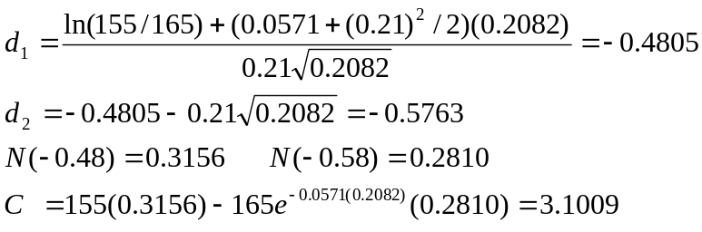

August 170 call

This result is calculated by hand in problem 6-12.

C=0.1119.
Value of Diagonal spread = 3.1009-0.1119 = 2.9890

Π= 100(2.9890-8.125+3.25) = -188.60

These results are noticeably different from the values computed using a spreadsheet (see below) but the difference is due to the black-scholes model’s sensitivity to round off errors

S_{T} | Option Price at End of Holding Period |  | Profit
 | October 165 Call | August 170 Call
150 | 1.5867 | 0.0164 | -330.4700
155 | 2.8800 | 0.1083 | -210.3300
160 | 4.7666 | 0.4793 | -58.7700
165 | 7.2909 | 1.5084 | 90.7500
170 | 10.4321 | 3.5836 | 197.3500
175 | 14.1154 | 6.8145 | 242.5900
180 | 18.2350 | 10.9577 | 240.2300

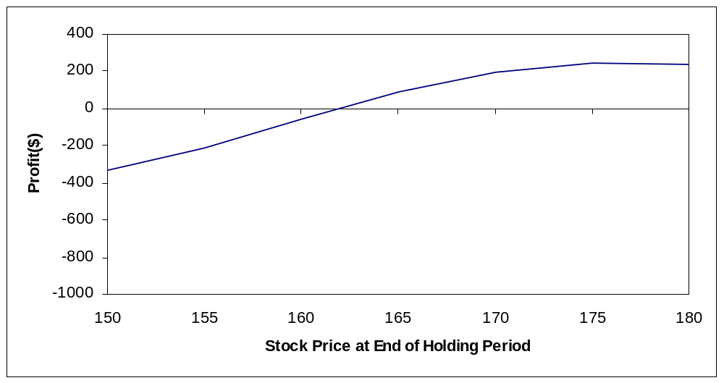

The breakeven is approximately 161.9

